Computerized Systems Development Life Cycle (SDLC)

Function: | Prepared by: | Reviewed by: | Approved by:
Department: | Quality Assurance | Systems and cybersecurity | Quality Assurance
Name: | Ivan Perez | David Pozo | Fernando Pozo
Signature:
Date:

Valid until: | 02/06/2028

DOCUMENT HISTORY
VERSION | CAUSES OF MODIFICATION | EFFECTIVE DATE | REPLACES (CODE, REVISION)
01 | Initial edition | 22/02/2024 | N/A
02 | Change in Spika's departments | 02/06/2025 | PNT-027.01

Content
1. Objective 4
2. Scope 4
3. Responsibilities and Departments affected 4
4. Definitions and Acronyms 5
5. Procedure 5
5.1. Generalities 5
5.2. Software Classification 7
5.3. Planning 10
5.3.1. Software requirements analysis. 10
5.4. Design 11
5.5. Construction and coding 12
5.6. Tests 12
5.7. Operation and Maintenance 12
5.7.1. Maintenance plan 13
6. Distribution of Procedure 13
7. Annexes 14
8. Related documentation 14
9. Formation 14
Software Classification 15

- Aim
The objective of this procedure is to describe the process of the Computerized Systems Development Life Cycle, hereinafter SDLC, in English , Software Development Life Cycle, including the software validation life cycle, in Spika Tech, hereinafter SPIKA.
- Scope
This SDLC process is applied to software developed at Spika to comply with regulations applicable to medical devices, as well as customer requirements, ensuring that the user meets the stated requirements. This ensures compliance with Spika's quality system.
- Responsibilities and Departments Affected
The research and development department is responsible for managing and documenting the life cycle of the systems developed by Spika.
The Technical Manager is responsible for overseeing the management of generated documents, as well as safeguarding them and maintaining copies. He or she will also be responsible for monitoring compliance with this procedure.
The affected departments are:

Department | Apply
 | Yeah | No
Address | ☒ | ☐
Environment | ☒ | ☐
Quality Assurance | ☒ | ☐
Systems and Cybersecurity | ☒ | ☐
Research and Development | ☒ | ☐
Marketing and Sales | ☒ | ☐
Management | ☒ | ☐

- Definitions and Acronyms
- Software element : any identifiable part of a computer program, for example, source code, object code, control code, control data, or a set of these elements.
- Release : A particular version of a configuration item that is made available for a specific purpose.
- SDLC: Software Development Lyfe Cycle.
- Procedure
  - Generalities
This procedure will provide controls over the system lifecycle and software documentation, and aims to control the following points:
- Configuration
- Exchange controls
- Version control
- Record Retention
- Information management
- Incident management
- Periodic review
- Approval/Release
The following diagram summarizes the phases of the life cycle:
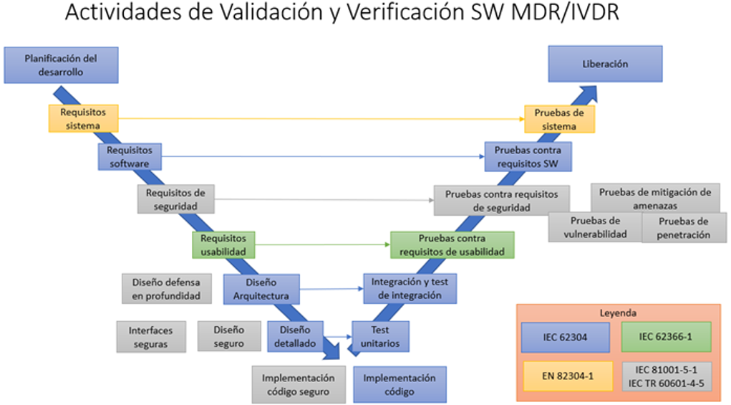
The generated documentation must be approved by a team that includes a representative with knowledge of regulatory standards and a quality representative, who must review and approve key stages of the project.
The documentation that will be used to implement the SDLC process may be the following, always depending on the criticality of the product:
- Validation Plan (VP): This will incorporate the results of the risk assessment and the validation phases, including their strategy, milestones, roles and responsibilities, and security classification. The plan must define the software development lifecycle or model to be followed.
- User Requirements (URS): Describes the requirements that the user needs to solve a problem or achieve objectives.
- Design Documentation (DQ) : The document content describes elements such as logical, control, and data structures, error messages, system configurations, security features, etc.
- Installation Qualification (IQ): Documents the installation, configuration, and qualification instructions for hardware and software, including middleware, to demonstrate that all of these items can perform the functions required by the application software.
- Test environment: This environment, separate from the production environment, ensures data independence and stability, in anticipation of errors.
- Validation test documentation: These are organized as follows, with special care being taken between phases and respecting the order of execution. With validation tests carried out under a protocol duly approved before their execution by the evaluation team, the activities will be documented to demonstrate the processes, methods, and data used in the structural and functional evaluation of the system.
The order of execution will be:
Installation Qualification (IQ )
Operation Qualification ( OQ)
Performance Qualification (PQ )
- System Installation and Implementation: Provides technical details and instructions on how to put the system into operation.
- Instructions for use : Describes information with instructions for use and operation.
  - Software classification
In the classification phase, the software's safety must be identified based on the risk of harm to the patient. The software will be identified as Safety Class A, B, or C, as follows:

CLASSIFICATION | EFFECTS OF DAMAGE
TO | You cannot contribute to a dangerous situation.
 | It may contribute to a hazardous situation that does not result in an unacceptable risk after considering the external risk control measures applied.
B | It may contribute to a hazardous situation resulting in an unacceptable risk after considering the external risk control measures applied and the resulting potential harm is a NON-SERIOUS injury.
C | You may contribute to a dangerous situation that results in an unacceptable risk after considering external risk control measures and the resulting potential harm is SERIOUS injury.
Below is a decision diagram for software classification and during the requirements gathering and development of software, the classification of the software must be documented following the scheme and argumentation included in Annex 1. If such classification does not exist, the software will be taken by default as class C. Once sufficient documentation exists, the corresponding class may be assigned.

Clase C (por defecto)
Clase A
Clase B
¿Puede producirse una situación peligrosa a causa de un fallo en el software?
NO

SI
Evaluar la efectividad de las medidas de control de riesgos externas al software

SI
¿El fallo resulta un riesgo inaceptable?
NO

SI
¿Qué severidad de lesión es posible?
NO

SI

Clase C

  - Planning
In the planning phase, the use of the system and the documentation required for the SDLC are identified. At this point, a risk management study can be used to determine the scope and extent of testing and associated documentation. The scope and depth of testing and phases may be condensed or omitted, with due justification.
In this phase, the URS are developed. The following points must also be addressed:
- The processes to be used in the development of the system, existing or new processes.
- The deliverables, including the documentation to be generated, activities and tasks
- Traceability between system requirements, software requirements, software system testing, and risk control measures
- Software configuration and change management
- Software troubleshooting to handle problems detected in products and activities at each stage of the lifecycle.
    - Analysis of software requirements.
For each software system, the manufacturer must define and document the system requirements, which must include the following points:
REQUIREMENTS | DESCRIPTION/EXAMPLE
Functional and capacity requirements | Functions (purpose), physical characteristics (code language, platform, operating system), computing environment (hardware, memory size), need for support for enhancements.
Entrances and exits | Data characteristics, ranges, limits and default values.
Interfaces between the system and other systems | If applicable
Alarms | Software-driven operator warnings and messages
Safety requirements | Authentication, authorization, auditing, communication integrity
Fitness-for-use engineering requirements that are sensitive to human error and training | Support for manual operations, human-machine interactions, staff coercion, and highlighting areas of people's attention
Data definition and database requirements | Form, fit and function
Software installation and acceptance requirements | N/A
Requirements relating to operating and maintenance methods | N/A
User documentation to be developed | Manual
User maintenance requirements | N/A
Regulatory requirements | N/A
  - Design
The design phase includes software design specifications that describe how the software should function. That is, software requirements must be translated into a documented architecture that describes the software structure and identifies its elements. The implementation process and how risks can be mitigated by mapping user requirements to the developed design functionalities are discussed.
Design specifications related to:
- System architecture: hardware, software, communications, security, etc. requirements.
- Database: Logical and physical representation of data definitions, critical components, security, and database size.
- Interfaces: including user interfaces, navigation, and report design.
  - Construction and coding
In this phase, the system design is implemented in source code and configuration settings for use by the end customer. It is desirable to develop the testing protocols to be performed in this phase to verify proper operation.
  - Evidence
The testing phase verifies that the system operates according to the approved specifications in a test environment. The manufacturer must establish and perform a set of tests with a pass/fail criterion to ensure all software requirements are met.
Testing includes software exercises under known conditions and documented results. All detected issues must be logged, reviewed, and addressed before the product is put into service. At this point, the design, installation, operation, and performance qualification protocols will be used.
The tests are documented in detail, highlighting the maximum possible data value, such as screenshots, and always identifying who performed them, when they were performed, and a list of any anomalies found.
If changes are to be made after testing, in order to correct errors/anomalies, tests should be repeated, modified or additional tests performed, as appropriate, in the same way verifying that undesirable side effects have not been included by a change and where applicable reviewing the corresponding risk management activities.
  - Operation and Maintenance
During the operation and maintenance phase, the software is in the production environment and all changes to be made must be managed under a regulated change control system; see PNT-005 Change Control Management.
"software release" will occur , where the manufacturer must ensure that the software verification has been completed and that the results have been evaluated before release. The version of the software being released must be clearly indicated.
The manufacturer must establish procedures to ensure that the released product or software can be delivered at the point of use without distortion or unauthorized changes. These procedures must address the production and handling of media containing software, including, where applicable, the following points:
- Replication
- Labeled
- Storage
- Supply
    - Maintenance plan
A software maintenance plan must be established to perform maintenance process activities and tasks. This plan must address the following:
- Procedures for: Reception, documentation, evaluation, resolution and follow-up.
- Criteria for determining whether returns (see complaints) are considered a problem, see PNT-007 Complaints Management
- Using the risk management process
- Using the problem resolution process, see PNT-004 Nonconformity Management
- Using the Configuration Management Process
- Procedures for improvements, troubleshooting, fixes, and obsolescence.
Of information returns that occur after release.
In this phase, a backup or disaster recovery plan, as well as an incident and periodic monitoring system, are essential.
- Distribution of the Procedure
Staff members in the departments listed in Section 3 (Responsibilities and Affected Departments) must be provided with a copy of this procedure. In addition, controlled copy No. 1 will be submitted to the Archives for paper archiving.
Controlled copies to be issued:
Controlled Copy No. | Departments
1 | Archive
- Annexes
NO. / REV. | QUALIFICATION
1/01 | Software classification
- Related documentation
Code | QUALIFICATION
N/A | ISO 13485
N/A | Regulation 2017/745
N/A | UNE-EN 62304
SGC-004 | Non-conformity management
SGC-007 | Claims management
- Training
This version requires that the affected departments indicated in section 3 receive the training indicated below:
Mark with an X | Type of training
☒ | Theoretical (reading and understanding of the procedure)
☐ | Theoretical – Practical (If you select this option, contact the Responsible Technician)

Annex 1_VERSION_02

Software classification
SOFTWARE CLASSIFICATION
SECURITY EVALUATION
Description
Intended use
Ask | Answer |  |  | Justification
 | Yeah |  | No
1. Can the software produce a dangerous situation due to a system failure? | ☐ |  | ☐
2. Is software failure an unacceptable risk? (see note 1) | ☐ |  | ☐
3. Does the software failure cause non-serious injury? (see note 2) | ☐ |  | ☐
4.Does the software failure cause SERIOUS injury? | ☐ |  | ☐
NOTE 1: 2. If you answer yes, continue to point 3.
NOTE 2: 3. If you answer yes, you have finished the questionnaire, if you answer no, continue to question 4.

ANNEX 1/02
BOTTOM LINE |  | TO | ☐ | B | ☐ |  | C | ☐
Justification:
Reviewed by: | Signature: |  |  |  |  | Date:
Approved by: | Signature: |  |  |  |  | Date:

